**Ideation Phase**

**Define the Problem Statements**

|  |  |
| --- | --- |
| Date | 19 September 2022 |
| Team ID | PNT2022TMID13900 |
| Project Name | Project – PLASMA DONOR APPLICATION |
| Maximum Marks |  |

**Customer Problem Statement Template:**

Create a problem statement to understand your customer's point of view. The Customer Problem Statement template helps you focus on what matters to create experiences people will love.

A well-articulated customer problem statement allows you and your team to find the ideal solution for the challenges your customers face. Throughout the process, you’ll also be able to empathize with your customers, which helps you better understand how they perceive your product or service.

By providing a user friendly and intuitive interface, a universal platform for donors to be listed, our application would be the go-to location for people to look for resources. This would be a vital improvement over the current, almost non-existent platform.

We want to facilitate efficient connection between donors and recipients. The application must provide notifications, reminders and updates regarding the progress of the donation process. It must also take into consideration the privacy and security of the information divulged in the application

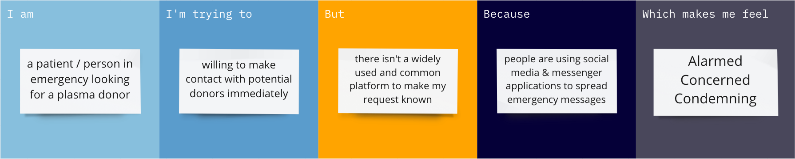

|  |  |  |  |  |  |
| --- | --- | --- | --- | --- | --- |
| **Problem Statement (PS)** | **I am** | **I’m trying to** | **But** | **Because** | **Which makes me feel** |
| PS-1 | a patient/person in emergency looking for a plasma donor | willing to make contact with potential donors immediately | there isn't a widely used and common platform to make my request known | people are using social media & messenger applications to spread emergency messages | Alarmed  Concerned  Condemning |